|  |  |  |  |
| --- | --- | --- | --- |
| **Team number** | 6 | **Section** | 3 |
| **Team Members** | 1. John Hoang 2. Isabel Pham 3. Ngan Luu 4. Anthony Nguyen | | |
| **Software Name** | JINA Studios | | |

## Problem Statement

The project is going to be an offline arcade program. The target audience for the application would be anyone who wants to play a collection of retro games.

## Product Objective

This program allows users access to interactive entertainment while their internet is down as well as providing several games to pick and choose from. The target audience for the application would be anyone who wants to play a collection of retro games.

## Functional Requirements

List of major features:

* 1. Select and play a variety of retro arcade games (ie.)
     1. Snake
     2. BlockBreaker
     3. Pong
     4. Tetris
  2. Customize functions/variables within the game
     1. Settings function
        1. Change colors for users with colorblindness
  3. Achieve high scores as well as store them for future attempts
  4. Point System Shop
     1. Points are accumulated through all runs in the game and only depletes when user buys an item in the point shop
     2. Items help user or provide tradeoffs in their next run

## Use Cases

|  |  |  |  |
| --- | --- | --- | --- |
| **Use Case Name** | | Exchange points for item(s) in Item Shop | |
| Goal | | | |
| This use case describes how a user may purchase an item in the item shop | | | |
| Participating Actors | | | |
| User  System | | | |
| Glossary | | | |
| Define any complex concepts, abbreviations or acronyms  **Item** - an entity that provides a specific condition in a game to help users or provide tradeoffs in their next run/round. An item is equivalent to a fixed amount of scores that the user earns. | | | |
| Primary Flow of Events | | | |
| Trigger | | | |
| User clicks on "Purchase" button | | | |
| **Steps** | **Action** | | **System Response** |
| 1 | User click “purchase” on item they want to select | | System deduct the User’s accumulated points by the cost of the item. System enables the customization change. |
| 2 | User exit item shop | | System returns back to Main Menu |
| 3 |  | |  |
| 4 |  | |  |
| 5 |  | |  |
| Alternate Flow of Events | | | |
| **Alternate Trigger** | | | |
| In Step 2, user does not have enough points to purchase the selected item | | | |
| **Steps** | **Action** | | **System Response** |
| 1 | User are unable to click on buttons | | System shows buttons but are unclickable depending on how many points the user has. |
| 2 | User exit item shop | | Proceed with Step 3: Return back to Main Menu |
| *3* |  | |  |

|  |  |  |  |
| --- | --- | --- | --- |
| **Use Case Name** | | Playing the game: Snake | |
| Goal | | | |
| User wants to play Snake on JINA Studios  This use case describes how a user interacts with the game Snake and quits Snake | | | |
| Participating Actors | | | |
| User and System | | | |
| Glossary | | | |
| The player in the game Snake move up, down, left, right to eat the food to grow longer | | | |
| Primary Flow of Events | | | |
| Trigger | | | |
| User clicks on "Snake” on games menu | | | |
| **Steps** | **Action** | | **System Response** |
| 1 | User presses the up arrow key | | Snake moves vertically upwards |
| 2 | User presses the down arrow key | | Snake moves vertically downward |
| 3 | User presses the left arrow key | | Snake moves horizontally left |
| 4 | User presses the right arrow key | | Snake moves horizontally right |
| Alternate Flow of Events | | | |
| **Alternate Trigger** | | | |
| User clicks on “Save Points” button | | | |
| **Steps** | **Action** | | **System Response** |
| 1 | User click on “Save Points” | | System redirect to a tiny menu showing points earned from the in-game round as well as the cumulative points.  Then, it redirects to Game Menu. |
| Alternate Flow of Events | | | |
| **Alternate Trigger** | | | |
| User clicks on “Exit Game” button | | | |
| **Steps** | **Action** | | **System Response** |
| 1 | User click on “Exit Game” | | System redirect to Game Menu without saving or adding the in-game score. |
| Alternate Flow of Events | | | |
| **Alternate Trigger** | | | |
| User presses “r” | | | |
| **Steps** | **Action** | | **System Response** |
| 1 | User presses “r” | | System reset in-game score and restarts a game round of Snake. |
| 2 |  | |  |

|  |  |  |  |
| --- | --- | --- | --- |
| **Use Case Name** | | Playing the game: Pong | |
| Goal | | | |
| User wants to play Pong on JINA Studios  This use case describes how a user interacts with the game Pong and quits Pong | | | |
| Participating Actors | | | |
| User  System | | | |
| Glossary | | | |
| Pong Box is essentially the player in the game Pong where they move strictly up or down to hit a ball into the opponent’s goal while blocking the user’s own game | | | |
| Primary Flow of Events | | | |
| Trigger | | | |
| User clicks on "Pong” on games menu | | | |
| **Steps** | **Action** | | **System Response** |
| 1 | User presses enter key | | Pong game starts |
| 2 | User presses the up arrow key | | User’s Pong paddle moves vertically upwards |
| 3 | User presses the down arrow key | | User’s Pong paddle moves vertically downward |
| 4 |  | |  |
| 5 |  | |  |
| Alternate Flow of Events | | | |
| **Alternate Trigger** | | | |
| User clicks on “Save Points” button | | | |
| **Steps** | **Action** | | **System Response** |
| 1 | User click on “Save Points” | | System redirect to a tiny menu showing points earned from the in-game round as well as the cumulative points.  Then, it redirects to Game Menu. |
| 2 |  | |  |
| Alternate Flow of Events | | | |
| **Alternate Trigger** | | | |
| User clicks on “Exit Game” button | | | |
| **Steps** | **Action** | | **System Response** |
| 1 | User click on “Exit Game” | | System redirect to Game Menu without saving or adding the in-game score. |
| 2 |  | |  |
| *3* |  | |  |

|  |  |  |  |
| --- | --- | --- | --- |
| **Use Case Name** | | Playing the game: Block Breaker | |
| Goal | | | |
| User wants to play Block Breaker on JINA Studios  This use case describes how a user interacts with the game Block Breaker and quits Block Breaker | | | |
| Participating Actors | | | |
| User  System | | | |
| Glossary | | | |
| Block Breaker box is essentially the player in the game Block Breaker where they move strictly left or right to hit a ball into the blocks near the top of the screen while keeping the ball bouncing without missing a hit | | | |
| Primary Flow of Events | | | |
| Trigger | | | |
| User clicks on "Block Breaker” on games menu | | | |
| **Steps** | **Action** | | **System Response** |
| 1 | User presses the left arrow key | | User’s Block Breaker box moves horizontally left |
| 2 | User presses the right arrow key | | User’s Block Breaker box moves horizontally right |
| 3 |  | |  |
| 4 |  | |  |
| 5 |  | |  |
| Alternate Flow of Events | | | |
| **Alternate Trigger** | | | |
| User clicks on “Save Points” button | | | |
| **Steps** | **Action** | | **System Response** |
| 1 | User click on “Save Points” | | System redirect to a tiny menu showing points earned from the in-game round as well as the cumulative points.  Then, it redirects to Game Menu. |
| 2 |  | |  |
| Alternate Flow of Events | | | |
| **Alternate Trigger** | | | |
| User clicks on “Exit Game” button | | | |
| **Steps** | **Action** | | **System Response** |
| 1 | User click on “Exit Game” | | System redirect to Game Menu without saving or adding the in-game score. |
| 2 |  | |  |
| *3* |  | |  |

|  |  |  |  |
| --- | --- | --- | --- |
| **Use Case Name** | | Playing the game: Tetris | |
| Goal | | | |
| User wants to play Tetris on JINA Studios  This use case describes how a user interacts with the game Tetris and quits Tetris | | | |
| Participating Actors | | | |
| User  System | | | |
| Glossary | | | |
| Tetrimino is a geometric shape composed of four squares connected orthogonally. | | | |
| Primary Flow of Events | | | |
| Trigger | | | |
| User clicks on "Tetris” on games menu | | | |
| **Steps** | **Action** | | **System Response** |
| 1 | User presses the left arrow key | | User’s tetrimino moves one space to the left |
| 2 | User presses the right arrow key | | User’s tetrimino moves one space to the right |
| 3 | User presses the down arrow key | | User’s tetrimino moves one space downward |
| 4 | User presses the up arrow key | | User’s tetrimino rotates 90 degrees clockwise |
| 5 | User presses the spacebar key for the first time | | User’s current tetrimino is stored and the next tetrimino in queue is given to the player |
| Alternate Flow of Events | | | |
| **Alternate Trigger** | | | |
| User clicks on “Save Points” button | | | |
| **Steps** | **Action** | | **System Response** |
| 1 | User click on “Save Points” | | System redirect to a tiny menu showing points earned from the in-game round as well as the cumulative points.  Then, it redirects to Game Menu. |
| 2 |  | |  |
| Alternate Flow of Events | | | |
| **Alternate Trigger** | | | |
| User clicks on “Exit Game” button | | | |
| **Steps** | **Action** | | **System Response** |
| 1 | User click on “Exit Game” | | System redirect to Game Menu without saving or adding the in-game score. |
| 2 |  | |  |
| *3* |  | |  |
| Alternate Flow of Events | | | |
| **Alternate Trigger** | | | |
| User clicks on “New Game” button or presses “N” key | | | |
| **Steps** | **Action** | | **System Response** |
| 1 | User clicks on “New Game” button or presses “N” key | | System restarts Tetris game and refresh scores back to 0. |
| 2 |  | |  |
| Alternate Flow of Events | | | |
| **Alternate Trigger** | | | |
| User clicks on “Pause” button or pressed “P” key | | | |
| **Steps** | **Action** | | **System Response** |
| 1 | User clicks on “Pause” button or pressed “P” key | | System put the Tetris game in standstill.  Pause button changes text to “Resume” |
| 2 |  | |  |
| *3* |  | |  |

|  |  |  |  |
| --- | --- | --- | --- |
| **Use Case Name** | | Change to colorblind mode from Settings page | |
| Goal | | | |
| User wants to switch to colorblind mode  This use case describes how a user can change to color blind mode from the settings page | | | |
| Participating Actors | | | |
| User  System | | | |
| Glossary | | | |
| User wants to change to colorblind mode to have a more visual interaction with the games if the user has colorblindness | | | |
| Primary Flow of Events | | | |
| Trigger | | | |
| User clicks on the settings button on the main menu | | | |
| **Steps** | **Action** | | **System Response** |
| 1 | User presses the “Enable colorblind mode” button | | System changes Block Breaker, Snake, and Tetris color schemes to a colorblind oriented palette |
| 2 |  | |  |
| 3 |  | |  |
| 4 |  | |  |
| 5 |  | |  |
| Alternate Flow of Events | | | |
| **Alternate Trigger** | | | |
| User clicks on “Disable colorblind mode” button | | | |
| **Steps** | **Action** | | **System Response** |
| 1 | User click on “Disable colorblind mode” button | | System changes Block Breaker, Snake, and Tetris color schemes to their original color palette |
| 2 |  | |  |
| Alternate Flow of Events | | | |
| **Alternate Trigger** | | | |
| User clicks on “Exit to Main Menu” button | | | |
| **Steps** | **Action** | | **System Response** |
| 1 | User click on “Exit to Main Menu” | | System redirect to Main Menu |
| 2 |  | |  |
| *3* |  | |  |

## Mockup

Note: “Game Block” is a section reserved for the game

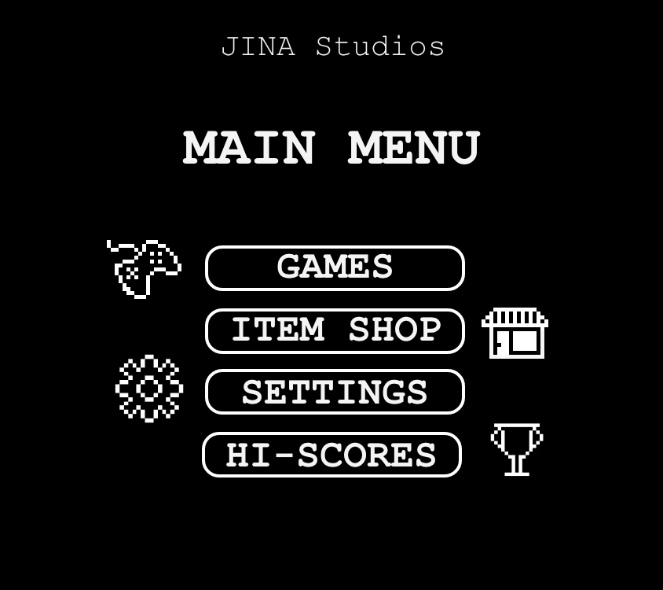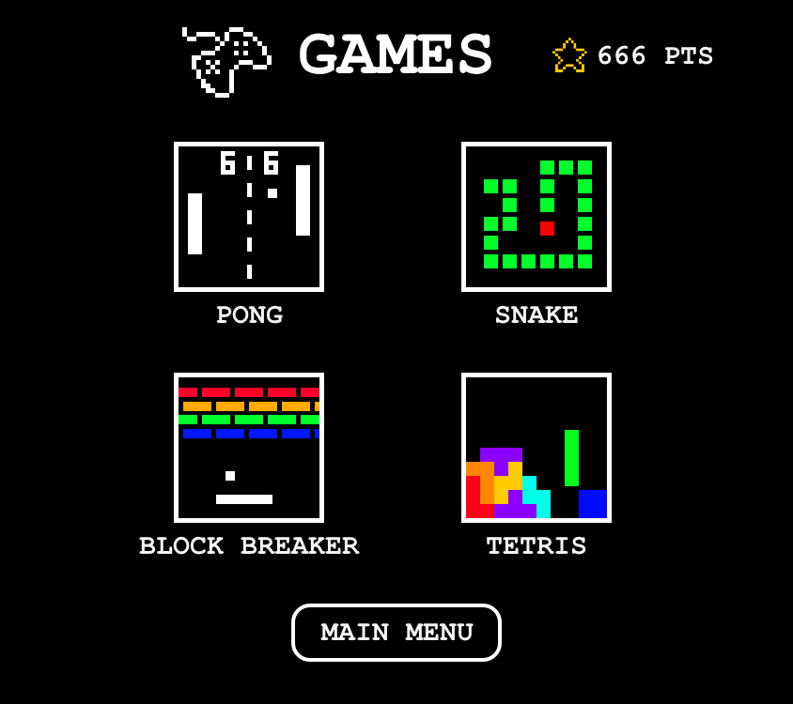

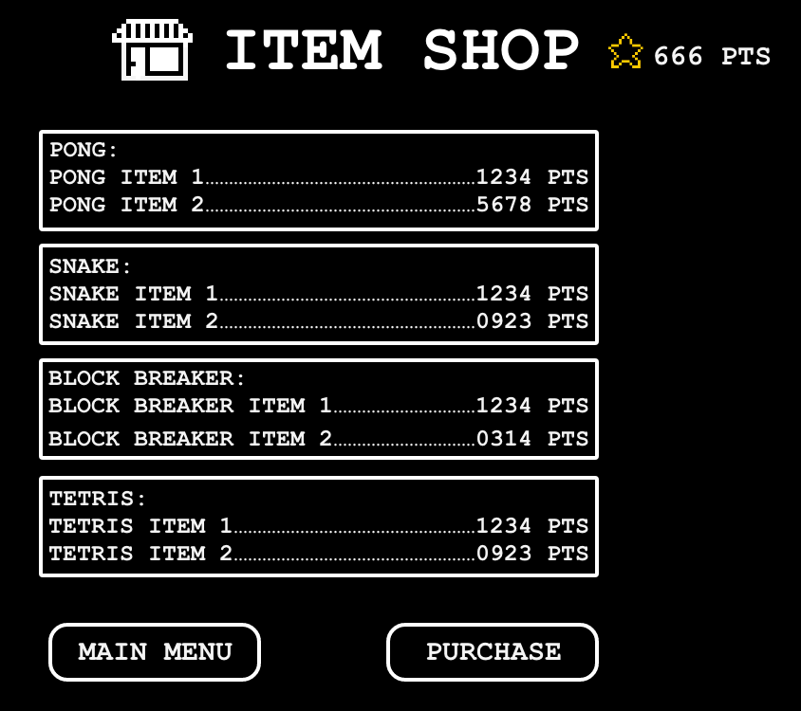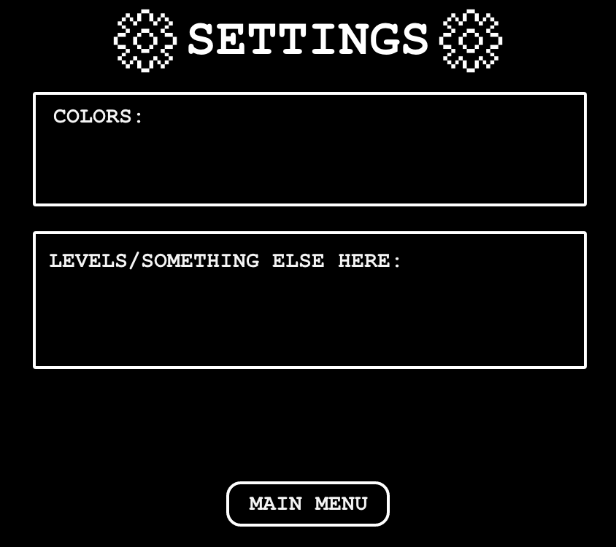

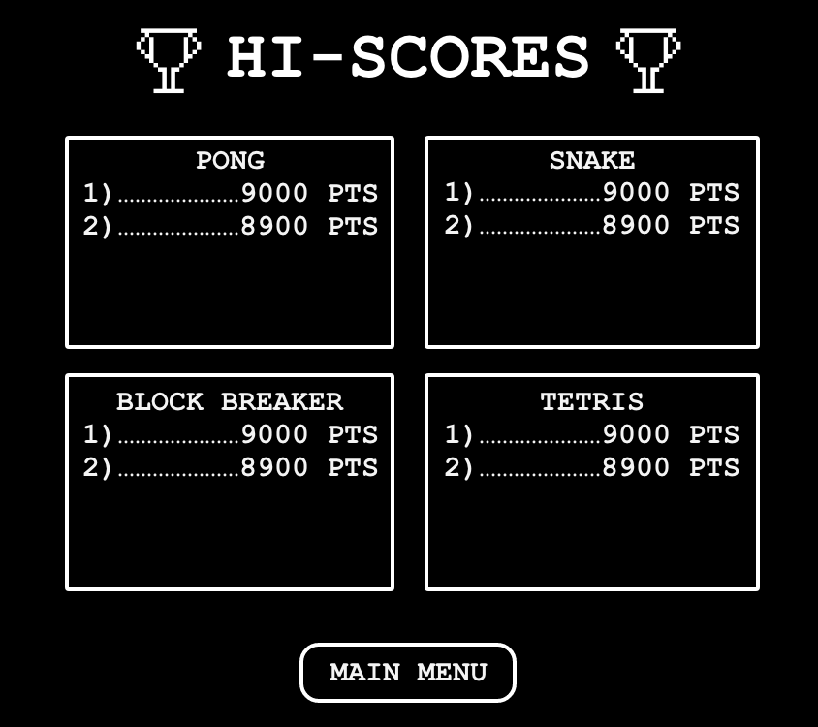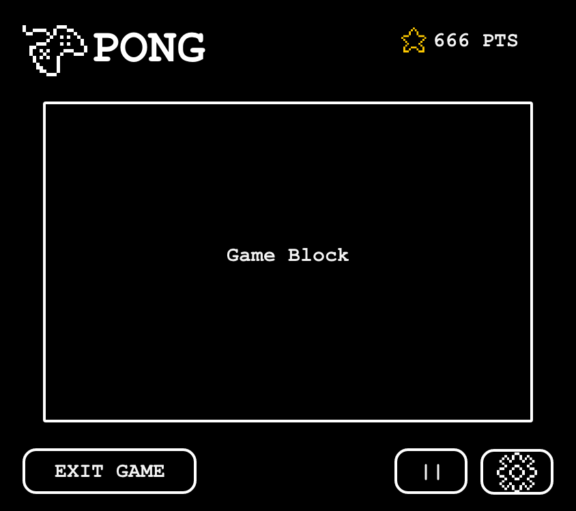

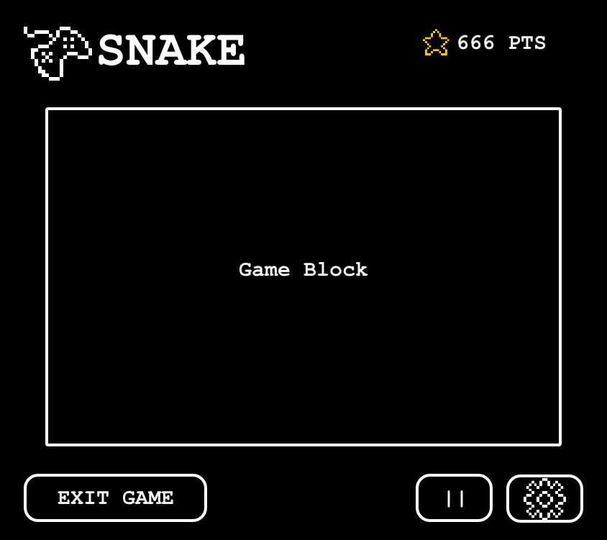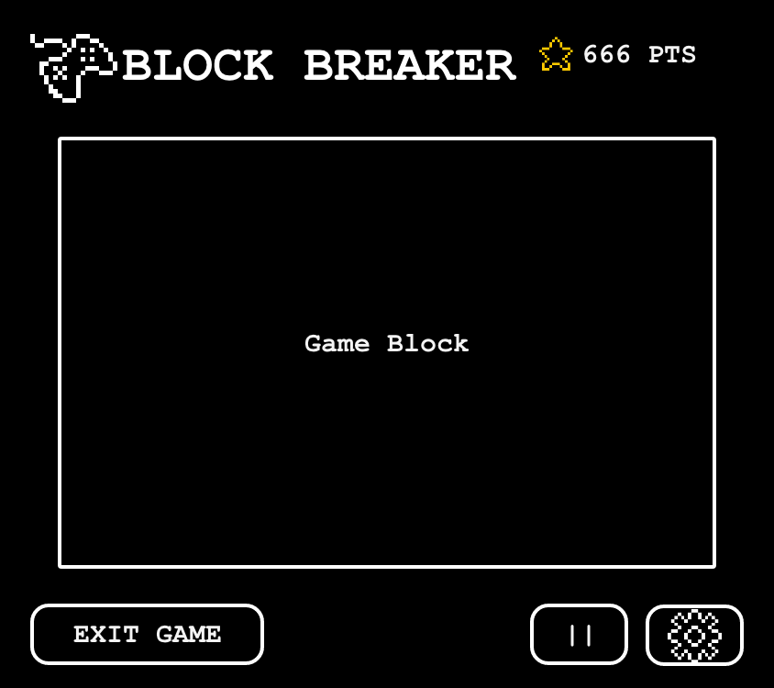

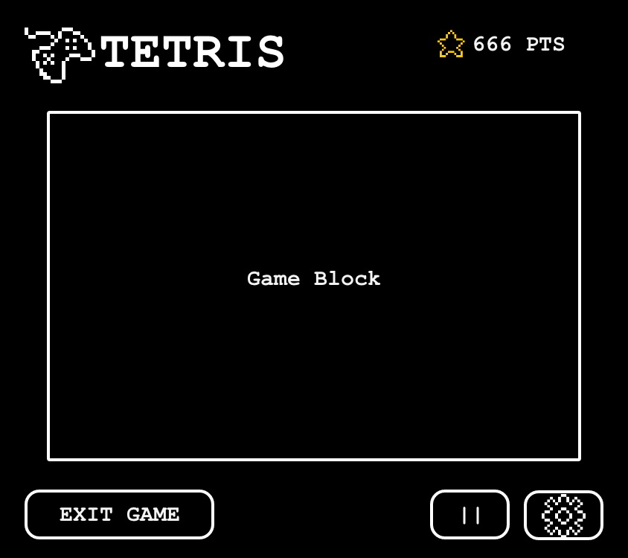

## Glossary

|  |  |
| --- | --- |
| Item | an entity that provide a specific condition in a game to help user or provide tradeoffs in their next run/round |
| Hi-Score | Hi-Score means “High Score” |
|  |  |